LUM GmbH moves into new headquarters in Berlin-Adlershof

Berlin, 8.8.2012: LUM GmbH is market leader in innovative analysers for direct and accelerated stability analysis and particle characterization of dispersions. Following the approved growth strategy, with the relocation a further important step forward is taken, now allowing LUM to offer customer solutions in the field of material testing, too.
Prof. Dr. Lerche, Managing Director of LUM GmbH, explains:
„After 18 years in the Innovation and Business Incubation Centre / International Business Incubator IGZ/OWZ we gratefully thank their team for the good collaboration, allowing LUM to grow from a start-up business to a market leading company. But, as an established company we have reached space limits. In our new headquarters Justus-von-Liebig-Strasse 3 in Germany's most successful science and technology park Berlin Adlershof, we move to an area of approximately 1500 square meters, fully designed and finished according to our needs and based on state-of-the-art aspects. Thereby, we have best preconditions to continue with our growth. The significant enlargement of the production area permits a more efficient production of the new Adhesion Analyser LUMiFrac in parallel to the existing product lines LUMiSizer, LUMiFuge, LUMiCheck as well as to the recently introduced multi-wavelength LUMiReader PSA. In addition, there will be enough space for the measuring instrument LUMiReader X-ray, currently in the construction type approval procedure. The application department is extended by several fully equipped laboratories and seminar rooms, allowing a comprehensive education and training of customers, independent of internal operating schedules of LUM. We intentionally decided for the new site, since we see us in the tradition of Justus von Liebig, too.
Justus Freiherr von Liebig (1803-1873) was a German chemist who made major contributions to agricultural and biological chemistry, and worked on the organization of organic chemistry.[1]
LUM instruments are standard equipment in agrochemical and other research and industrial laboratories around the world and solve challenges of the researching and producing ’inheritors’ of Justus von Liebig.“
LUM GmbH would like to thank Europäische Union –Programm „Investition in Ihre Zukunft“, Europäischer Fond für regionale Entwicklung and Strukturfonds in Berlin for the support of the construction project.

[1] http://en.wikipedia.org/wiki/Justus_von_Liebig 7.8.2012

LUM GmbH
Prof. Dr. Lerche (GF)
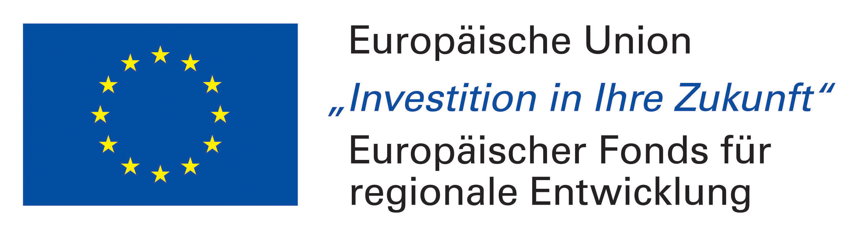
Justus-von-Liebig-Str. 3
12489 Berlin
Tel. +49-30-6780 6030
Fax +49-30-6780 6058
support@lum-gmbh.de
www.lum-gmbh.com

